

**Guided Capstone Step Two: Data Ingestion**



**Data Ingestion Instructions**

After downloading the project files, log into Azure Databricks. Import the project file by navigating to your home directory, going to your workspace, selecting user, then import from the drop down - as shown below.

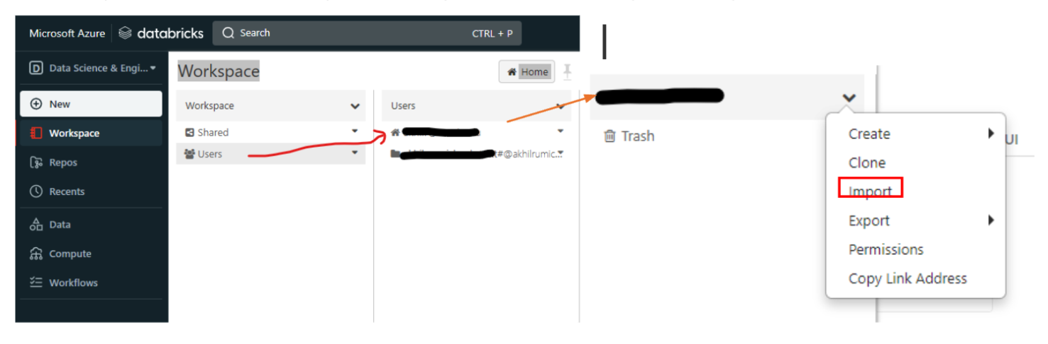

This will open an import page. Make sure that you are importing from a file and then upload banking_lab.dbc - which is provided to you in the project files.

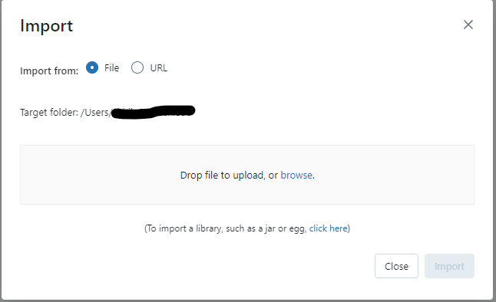



As your

Open the lab in DataBricks. You’ll find a notebook with a number of questions or prompts - in comments throughout the notebook marked with a #. Fill out the required Python and PySpark code to complete each task.

When you finish, turn in your completed lab and discuss any questions you may have with your mentor.